SUPPLEMENTAL FIGURES
Figure S1. Confidence intervals at 95% of R₀ across models and for each modelling approach of setting I. Replicates are ordered by increasing median value found in MS. Dashed line corresponds to the true value of R₀

Figure S2. Confidence intervals at 95% of δ across model and for each modelling approach of setting I. Replicates are ordered by increasing median value found in MS. Dashed line corresponds to the true value of δ

Figure S3. Confidence intervals at 95% of π across model and for each modelling approach of setting I. Replicates are ordered by increasing median value found in MS. Dashed line corresponds to the true value of π

Figure S4. Influence of variability in model selection and model averaging procedures on model k=4 d⁻¹ and V₀=10⁻⁴ copies.mL⁻¹ (setting I). Top row shows the percentage of selected models using the AIC criterion. Middle row presents the boxplot of weights using the AIC criterion. Bottom row shows the coverage rates of parameters R₀ (dots), δ (triangles) and π (squares)
Figure S5. Confidence intervals at 95% of R₀ across model and for each modelling approach of setting II. Replicates are ordered by increasing median value found in MS. Dashed line corresponds to the true value of R₀
Figure S6. Confidence intervals at 95% of δ across model and for each modelling approach of setting II. Replicates are ordered by increasing median value found in MS. Dashed line corresponds to the true value of δ

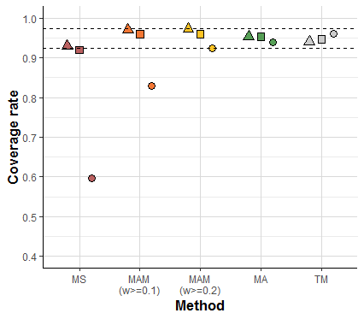
Figure S7. Coverage of the scenario with k=20 d⁻¹ and V₀=10⁻⁴ of setting including MS, MA, TM and MAM considering models with weights greater than 0.1 or 0.2. Triangles stand for the coverages of δ, squares for π, and circles for R₀

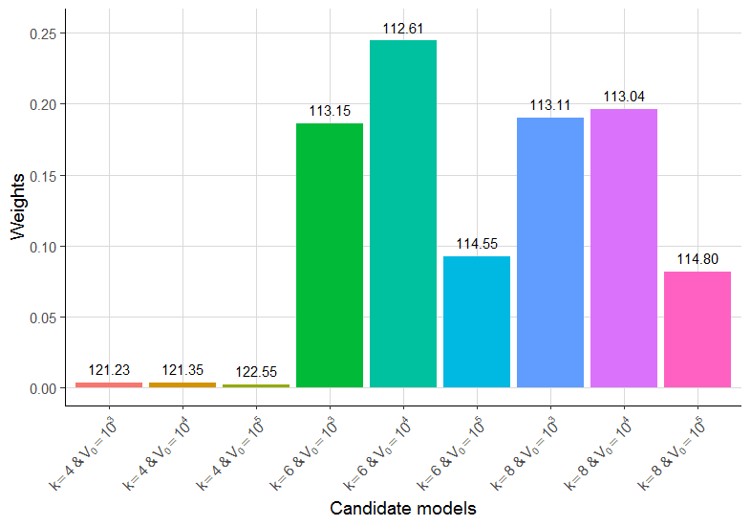
Figure S8. Distribution of weights given the data of Best et al. PNAS 2017. Nine candidate models were tested with values of k and V₀ ranging from 4 to 8 d⁻¹ and 10³ to 10⁵ respectively

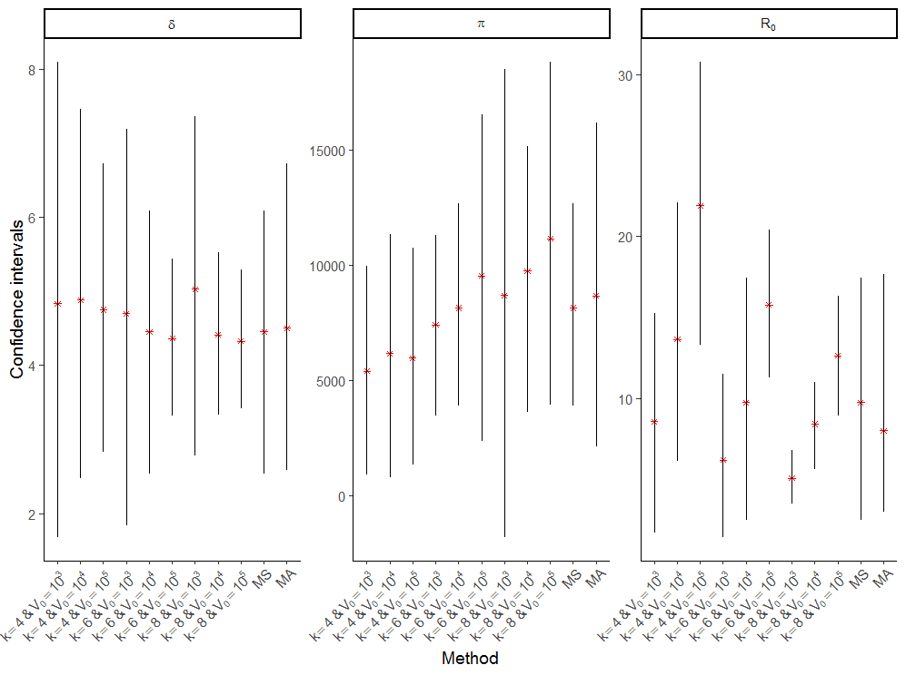
Figure S9. Confidence intervals of δ, π and R₀ for each candidate model, for the selected model (MS) and in model averaging (MA)

