Supporting Information for:

Bisquinolinium Compounds induce Quadruplex-Specific

Transcriptome Changes in HeLa S3 Cell Lines.

Rashi Halder,¹ Jean-Francois Riou,² Marie-Paule Teulade-Fichou,³ Tancred Frickey,⁴ and Jörg S. Hartig^{1*}

1: Department of Chemistry and Konstanz Research School Chemical Biology (KoRS-CB), University of Konstanz, Universitätsstraße 10, 78457 Konstanz, Germany
2: Structure des Acides Nucléiques, Télomères et Evolution, INSERM U565, CNRS UMR 7196, Muséum National d’Histoire Naturelle, 43 rue Cuvier, 75231 Paris cedex 05, France
3: Institut Curie, UMR 176-CNRS, Bât 110, Université Paris-Sud, 91405 Orsay, France
4: Department of Biology, University of Konstanz, Universitätsstraße 10, 78457 Konstanz, Germany

*To whom correspondence should be addressed. Tel: +49 7531 882398; Fax: +49 7531 885140; Email: joerg.hartig@uni-konstanz.de

Table S2 2
Table S3 3
Table S4 4
Figure S1 5

Table S2. Number of G-quadruplexes present in different subsets.
 | bf | br | af | ar
PhenDC3 and 360A – unchanged | 3311 | 2294 | 2998 | 2419
PhenDC3 – upregulated | 840 | 907 | 1202 | 889
PhenDC3 – downregulated | 592 | 707 | 810 | 589
360A – upregulated | 189 | 207 | 238 | 187
360A – downregulated | 85 | 100 | 111 | 74
bf: before forward, br: before reverse, af: after forward, ar: after reverse

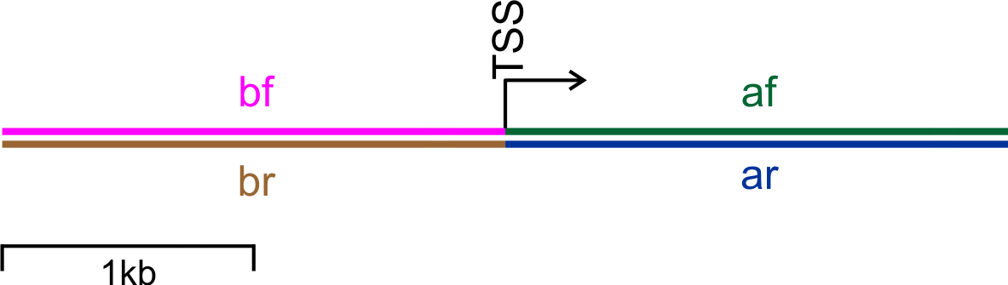
Table S3. Primers used for quantitative real time PCR
Gene symbol | Forward primer (5’-3’) | Reverse primer (5’-3’)
18S | GTAACCCGTTGAACCCCATT | CCATCCAATCGGTAGTAGCG
B2M | TGCTGTCTCCATGTTTGATGTATCT | TCTCTGCTCCCCACCTCTAA
CTPS2 | CCCAGTCTCATTGTTCCTCC | CCACAGAGTTTAGGCCAAATG
DPY30 | CGAGTTGGCAAAGACTGGAG | GAGTACGGTCTCACAGACAACG
DIO2 | TTGCTAAAACCTGATGGAGGA | CATGCTGACCTCAGAGGGA
EGFR | GTGACCGTTTGGGAGTTGATGA | GGCTGAGGGAGGCGTTCTC
CANX | GATGACTGGGATGAAGATGC | TCACATCTAGGGTTGGCAAT
PFKM | CCCTGACAGCAGCATTCATA | ATCATGACCCATGAAGAGCA
SH3GL1 | GCTGGTGACATCCACCTTCT | AGTTCTACAAGGCGAGCCAG
AK1 | TGTGAGAAGATCGTGCAGAA | CATGTCCAACACTGTCTCCA
TOGLN2 | TCAAAGCTGAAACGAGAGCA | AAGGCCAGTGACTACCAACG

Table S4. Enriched Gene Ontology (GO) classes of differentially expressed genes after treating HeLa S3 cells with 360A
GO ID | TERM | P VALUE
GO:0051234 | establishment of localization | 0.0002727
GO:0006810 | transport | 0.0003710
GO:0007049 | cell cycle | 0.0004002
GO:0016192 | vesicle-mediated transport | 0.0005539
GO:0051641 | cellular localization | 0.0006009
GO:0007041 | lysosomal transport | 0.0007979
GO:0051649 | establishment of localization in cell | 0.0008467
GO:0046907 | intracellular transport | 0.0009386
GO:0007034 | vacuolar transport | 0.0018062
GO:0033036 | macromolecule localization | 0.0018339
GO:0051179 | localization | 0.0019069
GO:0009411 | response to UV | 0.0023047
GO:0008104 | protein localization | 0.0023879
GO:0006897 | endocytosis | 0.0026701
GO:0010324 | membrane invagination | 0.0026701
GO:0016044 | membrane organization | 0.0029434
GO:0006613 | cotranslational protein targeting to membrane | 0.0039452
GO:0006622 | protein targeting to lysosome | 0.0039452
GO:0015031 | protein transport | 0.0043308
GO:0016197 | endosome transport | 0.0043486
GO:0008543 | fibroblast growth factor receptor signaling pathway | 0.0045231
GO:0045184 | establishment of protein localization | 0.0048901
GO:0015992 | proton transport | 0.0058074
GO:0007242 | intracellular signaling cascade | 0.0058668
GO:0034613 | cellular protein localization | 0.0067155
GO:0070727 | cellular macromolecule localization | 0.0069307
GO:0022402 | cell cycle process | 0.0071530
GO:0051246 | regulation of protein metabolic process | 0.0072770
GO:0006818 | hydrogen transport | 0.0072990
GO:0006886 | intracellular protein transport | 0.0073403
GO:0009987 | cellular process | 0.0077087
GO:0006605 | protein targeting | 0.0081032
GO:0030518 | steroid hormone receptor signaling pathway | 0.0086020
GO:0006766 | vitamin metabolic process | 0.0086020
GO:0009314 | response to radiation | 0.0090504
GO:0009755 | hormone-mediated signaling | 0.0099408
GO:0032886 | regulation of microtubule-based process | 0.0099561

Figure S1. Kernel density plot showing the distribution of individual nucleotides (A) A, (B) C, (C) G and (D) T or nucleotide groupings (E) AT, (F) CT and (G) GT that occur in loops of G-quadruplex motifs in af, ar, bf and br subsets (see Table S2).
