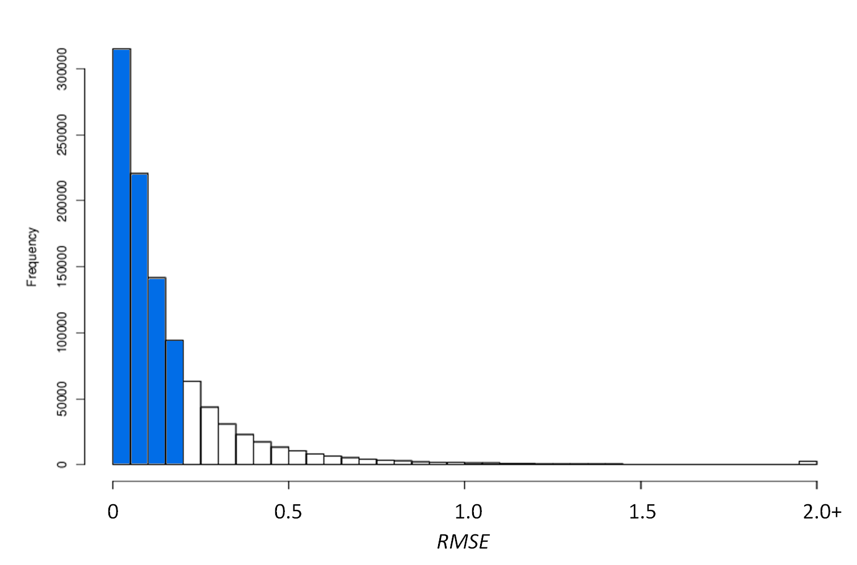

Additional file 2 – RMSE of OS with BPCA imputing method
RMSE value for OS for rate of missing value going from 0.5% to 20% by step of 0.5% with the L dataset.
This method is powerful for low rates of missing values. As seen here in blue, 76.2% of the data have RMSE values below 0.20. However it should be noted that the efficiency of BPCA is strongly reduced when the rate of missing data increases

